
Biology
Human Skin Color: Evidence for Selection
INTRODUCTION
Our closest primate relatives have pale skin under dark fur, but human skin comes in a variety of shades from pinkish white to dark brown. How did this variation arise? Many biological traits have been shaped by natural selection. To determine whether the variation in human skin color is the result of evolution by natural selection, scientists look for patterns revealing an association between different versions of the trait and the environment. Then they look for selective pressures that can explain the association.
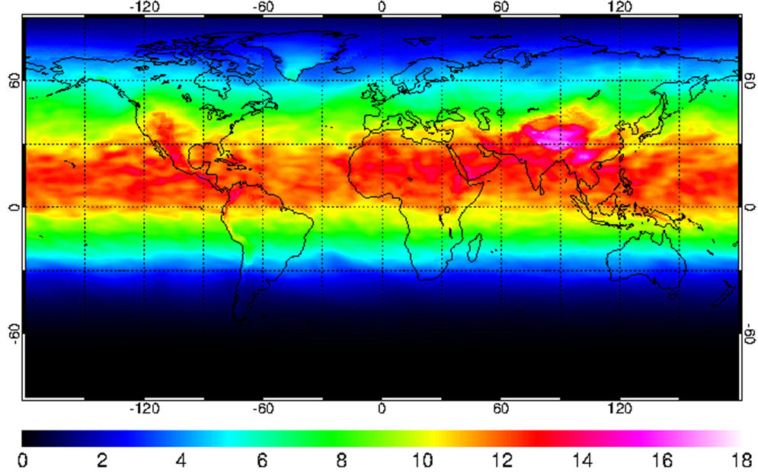
In this lesson, you will explore some of the evidence for selection by analyzing data and watching the film The Biology of Skin Color (http://www.hhmi.org/biointeractive/biology-skin-color), featuring anthropologist Dr. Nina Jablonski. El film La biología del color de piel (en español)

PART 1: Is There a Connection Between UV Radiation and Skin Color?
Watch the film from the beginning to timestamp 5:49 minutes. Pause when Dr. Nina Jablonski asks the question, “Is there a connection between the intensity of UV radiation and skin color?”
In this segment of the film, Dr. Jablonski explains that the sun emits energy over a broad spectrum of wavelengths. In particular, she mentions visible light that you see and ultraviolet (UV) radiation that you can’t see or feel. (Wavelengths you feel as heat are in a portion of the spectrum called infrared.) UV radiation has a shorter wavelength and higher energy than visible light. The level of UV radiation reaching Earth’s surface can vary depending on the time of day, the time of year, latitude, altitude, and weather conditions.
Dr. Jablonski has a hunch that melanin evolved in our skin to protect us from the sun’s harmful UV radiation, and that the most heavily pigmented human populations have evolved in areas of high UV intensity. This can account for the variability in human skin pigmentation only if different populations are exposed to different levels of UV light.
Dr. Jablonski asked her husband, Penn State University geographer George Chaplin, for help. At her request, he created a map showing the UV Index, a standardized scale that forecasts the intensity of UV radiation at any given time and location on the globe. Figure 1 shows an example of a similar map to the one George created.

Figure 1. Ultraviolet Radiation Index across the World. Recorded on July 15, 2017. The UV Index is a standardized scale of UV radiation intensity running from 0 (least intense) to 18 (most intense). The y-axis values are degrees of latitude, which range from the equator (0°) to the poles (90° north and −90° south). The x-axis values are degrees of longitude, which range from the prime meridian (0°) to the antimeridian (180° east and −180° west). (Source: European Space Agency, http://www.temis.nl/uvradiation/UVindex.htm
Stop and Respond
1. Describe the relationship between the UV Index (the colored bar in Figure 1) and latitude (y-axis).
The relationship between the UV index and the Latitude figure seems to represent the amount of UV light. In the bar it shows us the amount of UV light in a certain spot and we can substitute that into the matching color on the latitude world map. They can help us understand and see where the most UV light is located. Its most intense near the equator and least intense toward the poles.
2. How do you explain the relationship between the UV Index and latitude? (In other words, why does UV intensity change with latitude?)
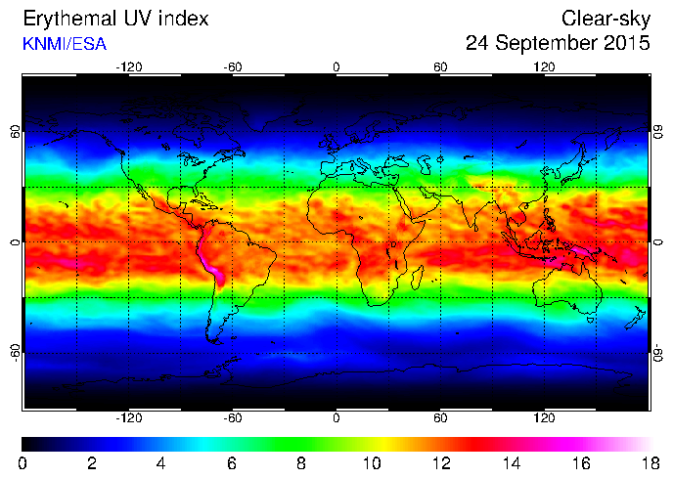
The UV intensity changes with latitude because Latitudes at the equator and the equator receive direct sunlight all year, the angle by which the earth is at can also be relative to this. The latitudes toward the poles receive sunlight but not as much as the equator. It does receive as much radiation over a larger area than the equator.
3. Find your approximate location on the map. What was the UV Index value of your state on July 15, 2017? It would approximately be between 7-8.
4. Look at the regions that receive the most-intense UV (light pink). Cite a specific piece of evidence from the map that a factor other than latitude was contributing to UV intensity on this day.
It can be observed on the map that the Himalayas have higher UV index value and its evidence that the UV intensity increases when the altitude is higher.
5. In the film, Dr. Jablonski explains that melanin, located in the top layer of human skin, absorbs UV radiation, protecting cells from the damaging effects of UV. Genetics determines the type of melanin (i.e., brown/black eumelanin or red/brown pheomelanin) and the amount of melanin present in an individual’s cells. Based on this data, make a claim about where you might expect to find lightly, moderately, and darkly pigmented people (i.e. producing different amounts of melanin) on the planet? What evidence can you use to support this claim?
I would expect lightly pigmented people to be found in Russia and Europe , while moderate skin tones would be found in America , and dark skin would be prevalent in Africa and in some parts of Asia, because the sun hits them the most towards those countries. Mostly because they are located towards the equator
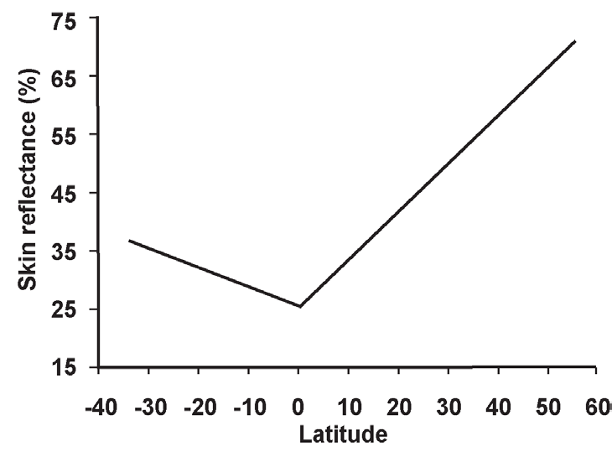
Evidence that supports this claim includes information on the latitude map where it shows us that the amount of UV light exposure is extremely high in Africa, and parts of Asia while the lowest exposures are in America and Russia.
One way to measure skin color is by skin reflectance. Scientists can shine visible light on a portion of skin (typically the inside of the arm) and then measure how much light is reflected back. Dark skin reflects less visible light than does light skin. The lower the reflectance value, therefore, the darker the skin. Examine Figure 2 before answering the following questions.

Figure 2. Relationship Between Skin Reflectance and Latitude.
This figure shows how skin reflectance changes with latitude. Negative latitudes are south of the equator (located at 0°), and positive latitudes are north of the equator. Available reflectance data from multiple sources were combined to form this graph. All combined data were obtained using a reflectometer with an output of 680 nanometers (i.e., a wavelength of visible light) and placed on the subjects’ upper or lower inner arms. (Source: Panel B of Figure 2 in Barsh (2003). Graph originally captioned as “Summary of 102 skin reflectance samples for males as a function of latitude, redrawn from Relethford (1997).” © 2003 Public Library of Science.)
Stop and Respond
6. What is/are the pattern(s) between skin reflectance (x-axis) and latitude (y-axis)? Consider both the direction and steepness of the lines’ slopes.
Skin reluctance increases when you move north and south from the equator, this means that skin pigment is darker near the equator but its lighter once you move north and south.
7. Does this support or refute your hypothesis from Question 5? Justify your answer.
This does nor support my previous hypothesis in question 5. This is because the graph indicates that the darker skinned individuals live around the middle which would be the equator and the UV light is intense in that area.

Watch the film from timestamp 5:49 minutes to 9:08 minutes. Pause when Dr. Jablonski says, “That suggests that variation in human skin melanin production arose as different populations adapted biologically to different solar conditions around the world.” After watching this segment of the film, answer Question 8.
8. Based on what you know about skin pigmentation so far, suggest a mechanism by which UV intensity could provide a selective pressure on the evolution of human skin color. (In other words, propose a hypothesis that links skin color to evolutionary fitness, indicating why skin of a certain color might be a reproductive advantage in certain places.)
Having darker skin can decrease the risks of having skin cancer, it also protects circulating folate from being damaged by UV radiation. The folate in the skin which is vitamin-D can be broken down by the UV radiation and wouldn't be good for the people with no melanin.
PART 2: What Was the Selective Pressure?
Watch the film from timestamp 9:08 minutes to 12:19 minutes. Pause when Dr. Jablonski says, “For that reason, though it might cut your life short, it’s unlikely to affect your ability to pass on your genes.” After watching this segment of the film, answer Questions 9–11.
Stop & Respond:
9. What does it mean for a trait, such as light skin coloration, to be under negative selection in equatorial Africa? Relate negative selective pressure to what we know about MC1R allele diversity among African populations.
In this situation this means that since it was found that among African ethnicity there isn't much MC1R allele variation, almost everyone has the allele that gives them dark skin. There is selection against MC1R alleles that dont give dark skin.
10. Why does Dr. Jablonski dismiss the hypothesis that protection from skin cancer provided selection for the evolution of darker skin in our human ancestors?
Skin cancer cannot arise until a person's reproductive years are at peak. To be affected by natural selection a trait must have an effect on the person's ability to survive and pass it on to their genes.
11. Revisit your hypothesis from Question 8. Based on the information you have now, does this seem like a more or less probable hypothesis than when you first proposed it? Provide evidence to support your reasoning.
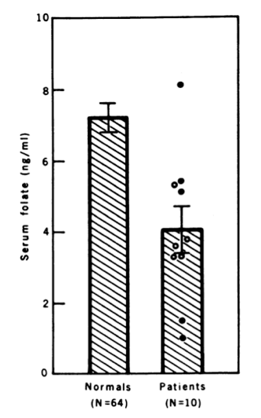
The hypothesis in Question 8 (having darker skin can decrease the risk of having skin cancer) now seems more probable because Africans have a limited variation of MC1R allele, implying that majority of Africans are dark.

Watch the film from timestamp 12:19 minutes to 13:32 minutes. Pause when Dr. Jablonski says, “That is what melanin does.” In this segment of the film, Dr. Jablonski references a paper she had read about the connection between UV exposure and the essential nutrient folate (a B vitamin), which circulates throughout the body in the blood. The paper, published in 1978, describes how the serum (blood) folate concentrations differed between two groups of light-skinned people. Examine Figure 3 and answer Questions 12–15.
Figure 3. Folate Levels in Two Groups of People. In one group (“patients”), 10 individuals were exposed to intense UV light for at least 30–60 minutes once or twice a week for three months. Sixty-four individuals not receiving this treatment (“normals”) served as the control group. The difference between the two groups was statistically significant (p < 0.005). Brackets represent the standard error of the mean, and “ng/mL” means “nanograms per milliliter.” (Republished with permission of the American Assn for the Advancement of Science, from Skin color and nutrient photolysis: an evolutionary hypothesis, Branda, RF and Eaton, JW, 201:4356, 1978; permission conveyed through Copyright Clearance Center, Inc.)

Stop & Respond:
12. Based on Branda and Eaton’s results (shown in Figure 3), what is the effect of UV light on blood folate levels? Use specific data from the graph to support your answer.
As shown in figure 3, continued exposure to UV light decreases the levels of blood folate. Patients exposed to UV light had 4 ng/mL of serum folate while people in normal conditions had over 7 ng/mL.
This is supported by the argument that exposure to UV light degrades folate in blood. When an individual is exposed to UV light, folate undergoes photolysis, which lowers folate levels.
13. Based on the data, which skin tones are probably correlated with higher levels of folate?
The data indicate that dark skinned people have higher levels of folate, which means that they have adapted to natural selection for better survival.
14. Dr. Jablonski learned that low folate levels are linked to severe birth defects. She describes this as a “eureka moment.” What does this information tell you about folate’s ability to exert selective pressure on human skin color? (That is to say, can folate levels cause allele frequency changes in a human population? Does this selective force meet all the requirements of natural selection?) (Hint: Think about who would be at an advantage or at a disadvantage with respect to folate concentrations in the body!)
Folate levels can be a selection force for human skin color because dark skinned women have a higher probability of carrying normal fetuses to term compared to light skinned women.
PART 3: Why Aren’t We All Dark Skinned?
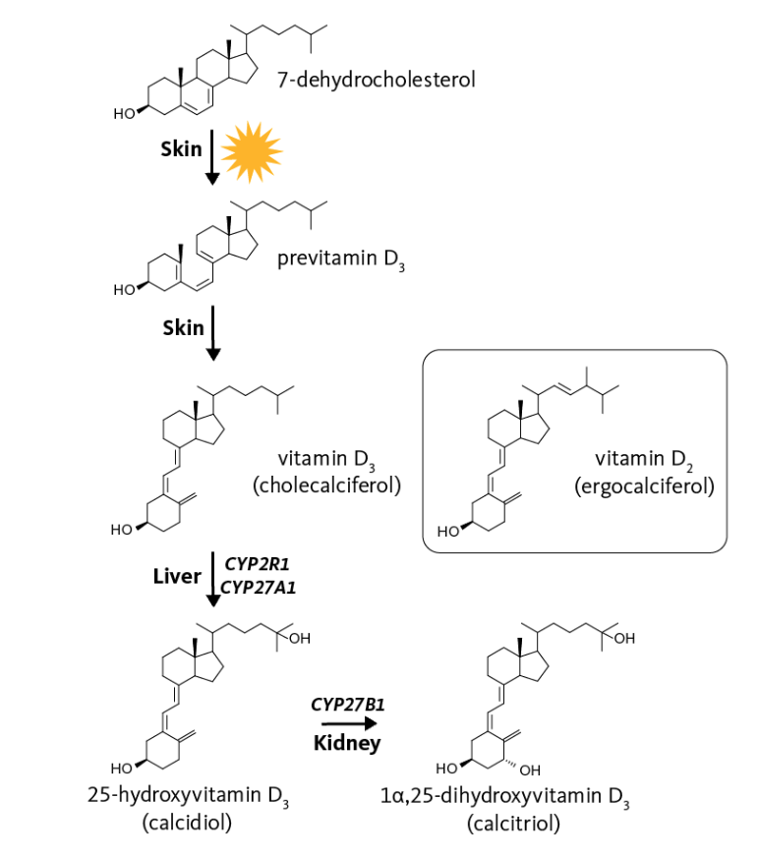
Watch the film from timestamp 13:32 minutes to 16:04 minutes. Pause when Dr. Jablonski says, “Support for the idea that the UV–vitamin D connection helped drive the evolution of paler skin comes from the fact that indigenous peoples with diets rich in this essential vitamin have dark pigmentation.”
Unlike many essential nutrients which must be included in the diet, vitamin D can be produced by the human body. One type of UV radiation called UVB starts a chain of reactions that convert 7-dehydrocholesterol—a chemical found in skin—to vitamin D. Vitamin D is essential to the absorption of calcium and phosphorus from the foods we eat to make strong bones. It is also important for reproductive health and for the maintenance of a strong immune system. Women have a higher need for this nutrient during pregnancy and breastfeeding due to their need to absorb calcium to build the fetal skeleton. How much UVB exposure is necessary to synthesize sufficient vitamin D depends largely on two factors: UVB intensity and skin color. In general, at a given UV intensity, a dark-skinned individual must be exposed to UVB five times as long as a light-skinned individual to synthesize the same amount of vitamin D.
Dr. Jablonski and Dr. George Chaplin published a paper in which they theorize whether available UV around the world would enable individuals with different skin colors to synthesize an adequate amount of vitamin D. Figure 5 and Table 1 summarize the results. Analyze Figure 5 and Table 1 and answer Questions 16–21.

Figure 4. Vitamin D synthesis. Image credit: Higdon, J., Drake, V., & Delage, B. (2000). Vitamin D. Retrieved from https://lpi.oregonstate.edu/mic/vitamins/vitamin-D
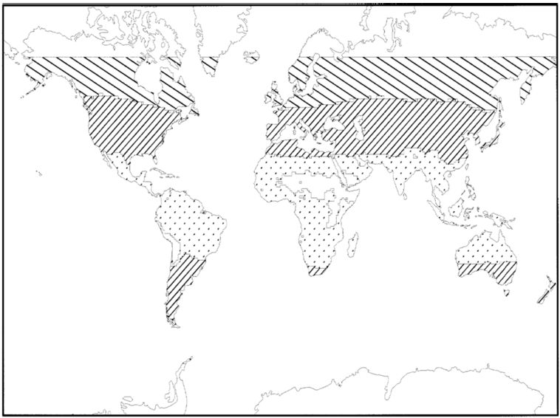
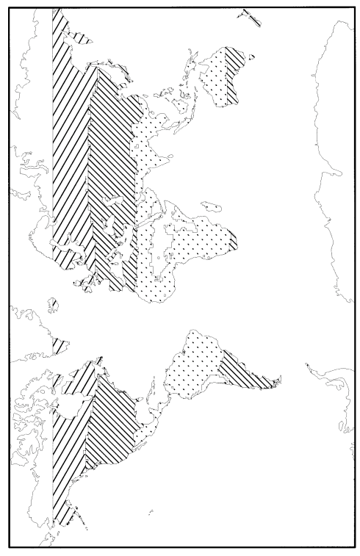
Figure 5. Comparison of Geographic Areas in Which Mean UVB Intensity Would Not Be Sufficient for Vitamin D Synthesis by Populations with Different Skin Colors. Widely spaced diagonal lines show regions in which UVB radiation, averaged over an entire year, is not sufficient for vitamin D synthesis by people with lightly, moderately, and darkly pigmented skin. Narrowly spaced diagonal lines show regions in which UVB radiation is not sufficient for vitamin D synthesis by people with moderately and darkly pigmented skin. The dotted pattern shows regions in which UVB radiation averaged over the year is not sufficient for vitamin D synthesis in people with darkly pigmented skin. (Reprinted from The Journal of Human Evolution, 39:1, Nina G. Jablonski and George Chaplin, The Evolution of Human Skin Coloration, 57-106, Copyright 2000, with permission from Elsevier.)

Table 1. Key to Zones in Figure 5.
Skin Pigmentation | Wide Diagonals (above 60 deg) | Narrow Diagonals (30 - 60 deg N and S) | Dots  (equator and tropics) | Note: “Y” means that an individual with that skin pigmentation could synthesize sufficient vitamin D in the region indicated throughout the year. “N” means that the person could not.
Light | N | Y | Y
Moderate | N | N | Y
Dark | N | N | N
Stop & Respond:
15. How do people with light skin and people with dark skin differ in their ability to produce Vitamin D? Cite evidence from the text.
Light skinned people synthesize vitamin D faster while dark skinned people experience a slow synthesis. Table 1 shows that light skinned people can synthesize sufficient vitamin D in two regions while dark skinned people are unable to synthesize vitamin D in the three regions.
16. How can lack of Vitamin D₃ affect reproduction?
Lack of vitamin D₃ can lead to poor quality of life, which in turn affects reproduction because vitamin D₃ helps improve sperm quality, improves reproductive health, improves the immune system, reduces premature births, and the risk of developing vaginal infections in mothers.
17. Based on these data, describe the populations least likely to synthesize sufficient levels of vitamin D. Explain your answer with data from the figure and/or the table.
The data indicate that dark skinned people cannot synthesize sufficient vitamin D in any of the designated areas, which means that they are least likely among the populations. They have 3 Ns, moderate have 3 Ns, and light skinned have 1 N. Figure 5 shows that populations near the equator are not able to synthesize vitamin D.
18. How do these data support the hypothesis that the evolution of lighter skin colors was driven by selection for vitamin D production?
Light skinned people would require more vitamin D compared to dark skinned people, which indicates that they have to synthesize more vitamin D in different regions.
19. For a person living farther away from the equator, would the risk of vitamin D deficiency be uniform or vary throughout the year? If it would vary, how would it vary? Explain your reasoning.
Due to the fact that skin reluctance increases when a person moves north or south of the equator, the risk of vitamin D deficiency would vary throughout the year. This evidence makes sense because at the equator, there is continuous sunlight while moving away from the equator implies varying periods of sunlight.
20. Vitamin D and folate levels in the blood are both affected by UV light. How would you predict that using a tanning booth would affect the blood levels of these two vitamins?
Using a tanning booth would affect vitamin D and folate levels in the blood because a tanning booth would increase the amount of circulating vitamin D and decrease the levels of folate.

CLAIM - EVIDENCE - REASONING Rubric for this assignment
Review your answers to the Stop and Respond questions above. Use them, as well as the data you’ve analyzed, to write a C-E-R answering the following prompt:

How have the different shades of skin color (from pinkish white to dark brown) evolved throughout human history?
Skin color in humans has evolved over the years under selection pressure from the intensity and duration of exposure to sunlight. People living near the equator were selected for their dark skin while those in northern and southern latitudes were selected for their light skin. The continuum of skin color is achieved by the presence of many genes, with each being expressed individually. Also, it is necessary to understand that the distribution of genes associated with skin color is not a random process. There are different genes involved in the process, some of which are associated with biosynthesis while others are associated with regulation of biosynthesis. The presence of different alleles determines the amount of melanin. Considering that dark skin protects the body from UV light, populations living near the equator had a darker skin compared to those living in the tropics. This evidence supports evolution of skin color because dark skinned populations were more fertile near the equator while light skinned people would reproduce optimally in the higher latitudes. Because of limited levels of skin pigmentation, light skinned people are able to synthesize higher levels of vitamin D to compensate the low levels of melanin. Increased vitamin D synthesis would increase their survival in higher latitudes and near the equator.
Use the Resource Sheet for Claim - Evidence Reasoning to help you. Keep in mind that to keep your writing flowing, you’ll probably have some reasoning after each piece of evidence.
References
Figure 3. Folate Levels in Two Groups of People.
Figure 5. Comparison of Geographic Areas in Which Mean UVB Intensity Would Not Be Sufficient for Vitamin D Synthesis by Populations with Different Skin
Table 1. Key to Zones in Figure 5.

